**Linux Network Analysis**

**ifconfig:**

## 

## ping:

## 

## netstat:-

## 

## traceroute

## 

**ARP Poisoning:**

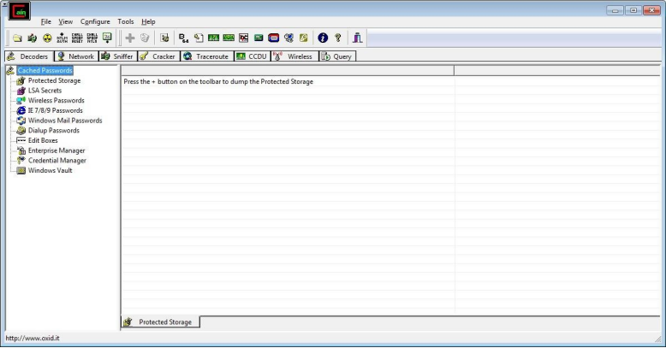

**Select sniffer on the top.**

|  |
| --- |
|  |
|  |  |

**Next to folder icon click on icon name start/stop sniffer. Select device and click on ok.**

|  |
| --- |
|  |
|  |  |

**Click on “+” icon on the top. Click on ok.**

|  |
| --- |
|  |
|  |  |

**Shows the Connected host.**

|  |
| --- |
|  |
|  |  |

**Select ARP at bottom.**

|  |
| --- |
|  |
|  |  |

|  |  |
| --- | --- |
|  |  |

**Click on start/stop ARP icon on top.**

|  |
| --- |
|  |
|  |
|  |  |

**Poisoning the source.**

|  |
| --- |
|  |
|  |  |

**Go to any website on source ip address.**

|  |
| --- |
|  |
|  |  |

**Go to password option in the cain & abel and see the visited site password.**

|  |  |
| --- | --- |
|  |  |